Assignment 1 (CO1) – Complete Solution

Item | Details
Name / Reg. No. | LOKESH S - 192572151
Course / Section | CSA0610 – DESIGN AND ANALYSIS OF ALGORITHM
Total marks | 50 (Tasks 1–11 = 42, Task 12 = 8)
Algorithms studied | A: Linear Search (iterative) B: Binary Search (recursive, on sorted data) C: Hash Table with chaining
Experiments | Python 3, n = 1,000 / 10,000 / 100,000 / 1,000,000, same data and queries for every algorithm

Summary of the solution
A university record system must decide whether a given registration number exists in a database of n records. Three genuinely different strategies are designed, analysed mathematically, implemented and measured: brute-force scanning (decrease-by-one / exhaustive), divide-and-conquer on sorted data (decrease-and-conquer by half), and transformation by hashing (space–time trade-off). All results below are from my own experiments (see Tasks 8–9 and the code in the Appendix).
 | A: Linear | B: Binary | C: Hash
Preprocessing | None | Sort: Θ(n log n) | Build table: Θ(n)
Search (worst) | n | ⌊log₂ n⌋ + 1 | n (rare); expected ≈ 1 + α
Search (average) | Θ(n) | Θ(log n) | Θ(1) expected
n = 10⁶: comparisons / search | 795,487 | 19.5 | 1.33
n = 10⁶: time / search | 30.0 ms | 2.576 µs | 0.160 µs

Task 1 – Design the Algorithm

Step 1: Understand the problem
Input: a collection of n unique registration numbers (integers) and a search key k. Output: the position of k (or "found"), or "not found". The data grows from 10³ to 10⁶+ records, so the algorithm must remain practical at every scale and any preprocessing must be charged to its cost.

Step 2: Choose three distinct strategies
The three strategies use different design paradigms, so they are not just variants of one another:
 | A: Linear Search | B: Binary Search | C: Hash Table
Design strategy | Brute force | Decrease-and-conquer (divide by 2) | Transform-and-conquer / space–time trade-off
Style used | Iterative | Recursive | Iterative (insert) + chain scan
Preprocessing | None – data may stay unsorted | Sort the array once | Build a table of m ≈ n buckets

Step 3: Algorithm A – Linear Search (iterative)
- Basic idea: compare the key with each record from the first to the last; stop when found or when the list ends.
- Why investigate it: it is the simplest correct baseline, needs no preprocessing and works on unsorted data. It shows exactly what the other two must beat.
- Preprocessing: none.
LinearSearch(A[0..n-1], key)
for i ← 0 to n-1 do
if A[i] = key then return i // basic operation
return -1

Step 4: Algorithm B – Binary Search (recursive)
- Basic idea: in a sorted array, compare the key with the middle element; the key can only be in one half, so discard the other half and recurse on the remaining half.
- Why investigate it: it exploits order to turn a linear scan into a logarithmic one and gives a natural recurrence for Tasks 6–7.
- Preprocessing: sort the registration numbers once (merge sort / Timsort, Θ(n log n)).
BinarySearch(A[lo..hi], key)
if lo > hi then return -1 // base case
mid ← ⌊(lo + hi) / 2⌋
if A[mid] = key then return mid // basic operation
else if A[mid] < key then return BinarySearch(A, mid+1, hi, key)
else return BinarySearch(A, lo, mid-1, key)
// initial call: BinarySearch(A, 0, n-1, key) on the SORTED array

Step 5: Algorithm C – Hash Table with chaining
- Basic idea: compute h(k) = k mod m to jump straight to one bucket; keys that collide are kept in a short list (chain) and only that chain is scanned.
- Why investigate it: it is a completely different paradigm (computation instead of comparison-driven elimination) and promises constant expected time, which matters for a heavily searched, rarely updated database.
- Preprocessing: allocate a table of m buckets (m = prime ≈ n, so load factor α = n/m ≈ 1) and insert all n records.
Build(A[0..n-1]) Search(T, m, key)
m ← prime ≥ n j ← key mod m
T[0..m-1] ← empty lists for each x in chain T[j] do
for each k in A do if x = key then return found // basic op
append k to T[k mod m] return not found

Task 2 – Identify the Basic Operation (2 marks)
The basic operation is the operation executed most often in the innermost part of the algorithm; the running time is proportional to its count. For all three algorithms it is the same kind of operation – a key comparison – but it occurs in different places and grows differently.
Algorithm | Basic operation & location | Why it is appropriate | How its count changes with n
A: Linear | A[i] = key, inside the for-loop body | Every loop iteration performs exactly one comparison plus constant bookkeeping, so time ∝ comparisons. | Grows in direct proportion to n (up to n comparisons).
B: Binary | A[mid] = key (and < key), once per recursive call | Each call does one three-way comparison and constant work; the total time is the number of calls. | Each call halves the range, so count grows only with log₂ n.
C: Hash | x = key, while scanning one chain | Computing h(k) is constant-time; the only variable work is scanning the chain. | Depends on chain length ≈ load factor α = n/m, which is kept constant, so count does not grow with n.

Task 3 – Derive the Time-Complexity Function (6 marks)
Input size: n = number of records in the database. Let q be the number of searches performed after the preprocessing.

Algorithm A – Linear Search
1. The loop runs once per examined element and does one comparison per iteration, so C(n) = number of elements examined.
2. Successful search for the element at position i (1 ≤ i ≤ n): C = i comparisons.
3. If each position is equally likely (probability 1/n): C_hit(n) = (1/n)·Σ_{i=1}^{n} i = (1/n)·n(n+1)/2 = (n+1)/2.
4. Unsuccessful search: all n elements are examined, C_miss(n) = n.
5. If a fraction p of searches succeed: C_avg(n) = p(n+1)/2 + (1−p)·n.
6. Running time T(n) = c₁·C(n) + c₀, hence T(n) = Θ(n). Preprocessing = 0, so total for q searches = q·n.

Algorithm B – Binary Search
1. Search cost. After i comparisons the remaining range has at most n/2^i elements. The search must stop when the range becomes empty, i.e. n/2^i < 1, so the worst case is C_worst(n) = ⌊log₂ n⌋ + 1.
2. Average successful search. View the comparisons as a balanced binary decision tree with n = 2^k − 1 nodes; level i holds 2^(i−1) nodes, each costing i comparisons: C_avg = (1/n)·Σ_{i=1}^{k} i·2^(i−1) = ((k−1)·2^k + 1)/(2^k − 1) ≈ k − 1 = log₂(n+1) − 1.
3. Search time T_search(n) = c·log₂ n + c′ = Θ(log n).
4. Preprocessing. Merge sort satisfies T_sort(n) = 2T_sort(n/2) + (n−1), which solves to n·log₂ n − n + 1 comparisons, i.e. Θ(n log n) (a worst-case-optimal comparison sort).
5. Total for q searches: T_total(n, q) = Θ(n log n) + q·Θ(log n) = Θ((n + q) log n).

Algorithm C – Hash Table with chaining
1. Preprocessing. Each of the n insertions computes k mod m and appends to a chain: Θ(1) each, so T_build(n) = Θ(n + m) = Θ(n) since m ≈ n.
2. Load factor α = n/m ≈ 1. Under simple uniform hashing every key is equally likely to land in any bucket, so the expected chain length is α.
3. Unsuccessful search scans a whole chain: E[C_miss] = α. Successful search scans on average half of the other keys in its chain plus itself: E[C_hit] = 1 + (n−1)/(2m) ≈ 1 + α/2.
4. Therefore T_search = Θ(1 + α) = Θ(1) expected, because α is held constant by choosing m ∝ n. Total for q searches: Θ(n + q).

Overall cost (preprocessing + searching)
Algorithm | Preprocessing | q searches | Total
A: Linear | 0 | q · Θ(n) | Θ(q·n)
B: Binary | Θ(n log n) | q · Θ(log n) | Θ((n + q) log n)
C: Hash | Θ(n) | q · Θ(1) | Θ(n + q) expected

Numerically for n = 10⁶: log₂ n ≈ 19.93, so sorting costs about n·log₂ n ≈ 2×10⁷ comparisons. One linear search averages 0.5×10⁶–10⁶ comparisons, so sorting pays for itself after roughly 20–40 searches in comparison terms (measured: 14 searches, Task 12).

Task 4 – Best, Average and Worst-Case Analysis (4 marks)

Algorithm A – Linear Search
- Best case: the key is the first record. One comparison, C = 1 (measured: 1). Occurs because the scan stops immediately on the first match. Θ(1).
- Average case: a successful search with the key equally likely at any position gives (n+1)/2 comparisons; with misses mixed in the average rises towards n. Measured for n = 10⁶ with 50% hits: 795,487 comparisons, close to the predicted 0.5·(n+1)/2 + 0.5·n ≈ 0.75n = 750,000.
- Worst case: the key is the last record or absent. Every element is compared, C = n (measured 1,000,000 at n = 10⁶). The algorithm has no way to rule out a position without looking at it.

Algorithm B – Binary Search
- Best case: the key sits exactly at the first midpoint: C = 1 (measured 1). Θ(1).
- Average case: successful searches average about log₂ n − 1 comparisons because half of all elements are at the deepest levels of the decision tree. Measured at n = 10⁶: 19.0 for hits, 19.46 for the 50/50 mix. Θ(log n).
- Worst case: the key is absent (or lies at the deepest level), so the range must shrink to empty: ⌊log₂ n⌋ + 1 = 20 comparisons for n = 10⁶ (measured maximum 20). The input order does not matter because the data is sorted; only the key's position matters.

Algorithm C – Hash Table
- Best case: the key is the first item in its chain, or the bucket is empty (a miss costs 0 chain comparisons): Θ(1).
- Average case: with uniform hashing and α ≈ 1, expected comparisons are about 1.5 for a hit and 1.0 for a miss. Measured at n = 10⁶ (50/50): 1.33 (sampling error with 100 queries explains the small gap from 1.25). Θ(1).
- Worst case: every key hashes to the same bucket (a poor hash function, or registration numbers sharing a pattern with m), producing one chain of length n and C = n, i.e. Θ(n). With a prime m and random-like keys the longest chain observed at n = 10⁶ was only 8.

Task 5 – Asymptotic Analysis (3 marks)
Algorithm | Best | Average | Worst | Tight bound
A: Linear | Ω(1) | Θ(n) | O(n) | Θ(n) for avg & worst
B: Binary search | Ω(1) | Θ(log n) | O(log n) | Θ(log n) for avg & worst
B: Sorting step | Ω(n log n) | Θ(n log n) | O(n log n) | Θ(n log n)
C: Hash search | Ω(1) | Θ(1) expected | O(n) | Θ(1) expected; O(n) worst
C: Hash build | Ω(n) | Θ(n) | O(n) | Θ(n)

Growth when the database grows from 1,000 to 1,000,000+
n | A: n | B: log₂ n | C: 1 + α | n·log₂ n (sort)
1,000 | 1,000 | 10.0 | ≈ 1–2 | ≈ 10⁴
10,000 | 10,000 | 13.3 | ≈ 1–2 | ≈ 1.3×10⁵
100,000 | 100,000 | 16.6 | ≈ 1–2 | ≈ 1.7×10⁶
1,000,000 | 1,000,000 | 19.9 | ≈ 1–2 | ≈ 2×10⁷

Interpretation: a 1000× increase in data multiplies linear search work by 1000×, binary search work by only 2× (10 → 20 comparisons), and hash search work by about 1×. For a university this means linear search becomes unusable as the database grows (one search at 10⁶ records takes about 30 ms, which is 20,000× longer than a hash lookup), while binary and hash searches remain effectively instant even if the data grows to 10⁹ records (binary needs only about 30 comparisons).

Task 6 – Formulate the Recurrence Relation (3 marks)
The recursive algorithm is Algorithm B. The recurrence is derived directly from the pseudocode in Task 1, counting key comparisons in the worst case.
1. Input size of the original problem: n = hi − lo + 1, the number of elements in the current range A[lo..hi].
2. Size of the subproblem: the call examines the middle element mid and then recurses on either A[lo..mid−1] (size ⌊(n−1)/2⌋) or A[mid+1..hi] (size ⌈(n−1)/2⌉ at most ⌊n/2⌋). In the worst case the larger half is chosen, so the subproblem size is at most ⌊n/2⌋.
3. Number of recursive calls: exactly one. The code contains two recursive call statements, but they are on mutually exclusive branches (if/else), so only one executes. Hence a = 1 (not 2) and b = 2.
4. Work outside the recursive call: computing mid and comparing A[mid] with key, a constant amount of work, f(n) = 1 comparison = Θ(1).
5. Base case: if lo > hi (empty range) the function returns −1 without comparing anything, T(0) = 0. For a single element, T(1) = T(0) + 1 = 1.
6. Combining the components:
T(n) = T(⌊n/2⌋) + 1 for n ≥ 1, T(0) = 0
(Supplementary: the preprocessing sort, if done by merge sort, has the recurrence T(n) = 2T(n/2) + (n − 1), T(1) = 0, from two recursive calls on halves plus a linear merge.)

Task 7 – Solve the Recurrence Relation (4 marks)

Why these methods are applicable
The recurrence has the form T(n) = aT(n/b) + f(n) with a = 1, b = 2, f(n) = 1, so the Master Theorem applies. I also solve it by backward substitution (iteration) to show the working and then prove the result by induction, since the Master Theorem hides the steps.

Method 1: Backward substitution (take n = 2^k)
T(n) = T(n/2) + 1
= [T(n/4) + 1] + 1 = T(n/4) + 2
= [T(n/8) + 1] + 2 = T(n/8) + 3
...
= T(n / 2^k) + k (general step after k substitutions)

The recursion stops when n/2^k = 1, i.e. k = log₂ n. Substituting T(1) = 1:
T(n) = T(1) + log₂ n = 1 + log₂ n ⇒ T(n) = ⌊log₂ n⌋ + 1 for general n, which is Θ(log n).

Method 2: Master Theorem
1. Identify a = 1, b = 2, f(n) = Θ(1).
2. Compute the critical exponent: n^(log_b a) = n^(log₂ 1) = n⁰ = 1.
3. Compare: f(n) = Θ(1) = Θ(n^(log_b a)), so Case 2 applies.
4. Case 2 gives T(n) = Θ(n^(log_b a) · log n) = Θ(1 · log n) = Θ(log n).

Verification by induction (substitution method)
Claim: T(n) ≤ log₂ n + 1 for all n ≥ 1. Base: T(1) = 1 ≤ log₂ 1 + 1 = 1 ✓. Step: assume it holds for ⌊n/2⌋. Then T(n) = T(⌊n/2⌋) + 1 ≤ (log₂(n/2) + 1) + 1 = log₂ n + 1 ✓.

Interpretation
Both methods give Θ(log n). For n = 10⁶ the recursion makes at most ⌊log₂ 10⁶⌋ + 1 = 20 calls, which exactly matches the measured worst-case count of 20 comparisons in Task 9. Doubling the database adds just one more comparison and one more stack frame, so the recursion depth (and stack space, Θ(log n)) stays tiny: about 20 frames for a million records. Because the recursion is tail-recursive it could also be converted to a loop with Θ(1) space.
For the sorting preprocessing, T(n) = 2T(n/2) + n has a = 2, b = 2, f(n) = Θ(n) = Θ(n^(log₂ 2)), so again Case 2 gives Θ(n log n).

Task 8 – Implement and Test the Algorithms (4 marks)

Step 1: Implementation
All three algorithms were implemented in Python 3 exactly as in the pseudocode: linear_search (iterative loop), bs_rec (recursive binary search with lo, hi parameters), and a chaining hash table with h(k) = k mod m, m = smallest prime ≥ n. Full source is in the Appendix. Instrumented copies count comparisons without changing the logic.

Step 2: Reproducible test procedure
- Dataset: n unique random 9-digit registration numbers (random.seed(42)), stored in random (unsorted) order. n = 1,000; 10,000; 100,000; 1,000,000.
- Queries: 100 per dataset, 50 existing keys and 50 absent keys, shuffled; the identical query list is given to all three algorithms.
- Preprocessing was timed separately (Python sorted() for B; table construction for C). Search time = average per query using time.perf_counter(), taking the best of several repeats (3 for linear on n ≤ 10⁵, 1 for linear on 10⁶, 5 for B and C) to reduce noise. All runs were on the same machine in one session.
- Correctness: for every dataset and every query, all three results were compared with Python's `in` operator using assert; no mismatch occurred.

Step 3: Test cases
Test case | Expected "found" | Result (A, B, C all agree)
Single element, present | True | PASS
Single element, absent | False | PASS
First element | True | PASS
Last element | True | PASS
Middle element | True | PASS
Absent, below minimum | False | PASS
Absent, above maximum | False | PASS
Absent, between values | False | PASS

Bulk correctness: 400 random queries (4 sizes × 100) against 3 algorithms = 1,200 checks, all correct.

Task 9 – Experimental Performance (3 marks)

Table 1: Average time per search
n | A: Linear | B: Binary (recursive) | C: Hash
1,000 | 0.020 ms | 1.167 µs | 0.149 µs
10,000 | 0.206 ms | 1.681 µs | 0.159 µs
100,000 | 2.422 ms | 2.191 µs | 0.227 µs
1,000,000 | 30.0 ms | 2.576 µs | 0.160 µs

Table 2: Average key comparisons per search (50% hits, 50% misses)
n | A: Linear | B: Binary | C: Hash
1,000 | 731 | 9.54 | 1.37
10,000 | 7,571 | 12.92 | 1.40
100,000 | 77,761 | 16.01 | 1.38
1,000,000 | 795,487 | 19.46 | 1.33

Table 3: Preprocessing time and special cases
n | Sort (B) | Build hash (C) | Linear best/worst | Binary best/worst | Max chain (C)
1,000 | 0.139 ms | 0.375 ms | 1 / 1,000 | 1 / 10 | 5
10,000 | 2.095 ms | 4.605 ms | 1 / 10,000 | 1 / 14 | 8
100,000 | 26.9 ms | 49.1 ms | 1 / 100,000 | 1 / 17 | 8
1,000,000 | 405.0 ms | 2113.3 ms | 1 / 1,000,000 | 1 / 20 | 8

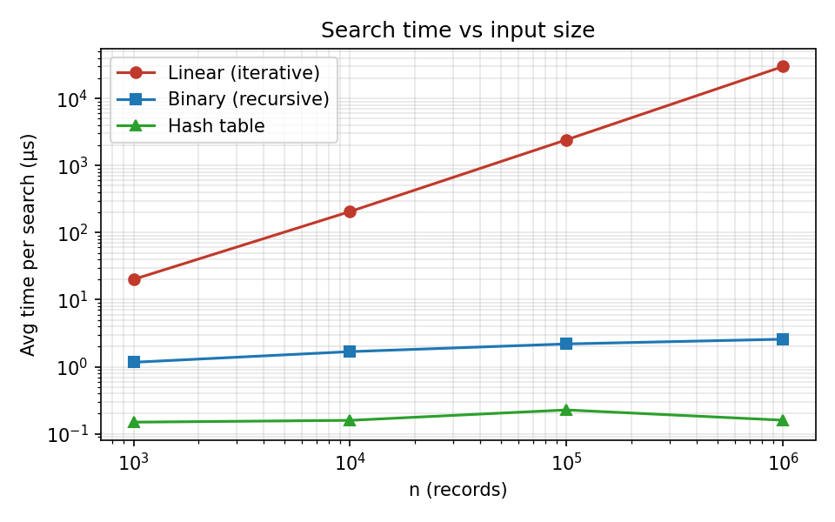
Figure 1: Average search time vs n (log–log scale). Linear has slope ≈ 1; binary and hash are almost flat.
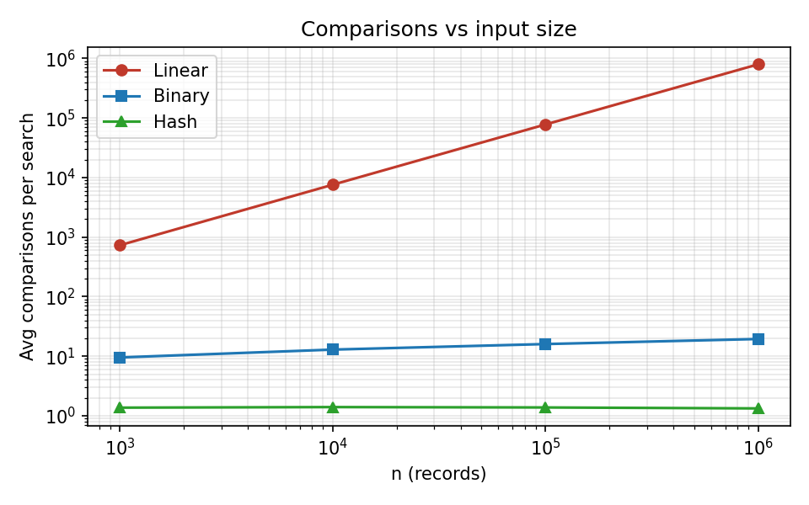
Figure 2: Average comparisons vs n (log–log scale).

Task 10 – Compare Theory with Experiment (4 marks)

Does the observed growth match the theory?
- Linear search: theory predicts the time grows ×1000 when n grows ×1000. Observed: 0.020 ms → 30.0 ms, a factor of about 1493. Comparisons rose from 731 to 795,487 (×1088), matching Θ(n). The average of ≈0.75n confirms the formula p(n+1)/2 + (1−p)n.
- Binary search: theory predicts comparisons proportional to log₂ n: 10 → 20, a factor of 2. Observed: 9.5 → 19.5 comparisons and 1.167 → 2.576 µs (×2.2). The worst case measured (20) equals ⌊log₂ 10⁶⌋ + 1 exactly, validating the recurrence solution.
- Hash table: theory predicts constant expected comparisons. Observed ≈ 1.3–1.4 at every size (1.37, 1.40, 1.38, 1.33), and time stays around 0.15–0.23 µs, which confirms Θ(1) expected time.

Which scales best?
Hash table scales best (flat), binary search next (very slowly increasing), linear search worst (proportional to n). At n = 10⁶ one hash lookup is about 187386× faster than a linear scan, and one binary search is about 11630× faster.

Differences between theory and practice, and reasons
- Linear time grew ×1493, not exactly ×1000. Cache effects: 1,000 integers fit in the CPU cache, but 10⁶ Python integer objects (tens of MB) do not, so each step is somewhat slower. Also the 100-query sample has random hit/miss positions, so averages vary.
- Hash build was slower than sorting. Theory says hash build Θ(n) < sort Θ(n log n), yet measured 2113.3 ms vs 405.0 ms at 10⁶. Python's sorted() is implemented in compiled C, whereas my hash table is built in interpreted Python with a million small lists and random memory writes (cache misses). This is an implementation constant factor, not a change in asymptotic order; with comparable implementations the Θ(n) build would be faster. The hash build also grew faster than ×1000 (×5635) for the same cache/memory-allocation reasons.
- Hash time is not perfectly flat (0.227 µs at 10⁵ versus 0.149 µs at 10³). Timings at this scale are in the range of measurement noise and memory-access effects; the comparison count (the machine-independent measure) is flat.
- Binary search ×2.2 versus predicted ×2: larger arrays cause more cache misses on the later probes, adding a little beyond the pure comparison count.
Conclusion: the experiments agree with the theoretical growth rates (n, log n, 1). The differences are constant-factor effects from the hardware and Python, which asymptotic analysis deliberately ignores.

Task 11 – Recommend and Defend the Final Design (4 marks)
Recommendation (original problem): sort the registration numbers once and use binary search (Algorithm B).

Why it is more appropriate than the alternatives
- Versus linear search: the one-off sort of 10⁶ records costs 405.0 ms, about 14 linear searches. After that, each search is 11630× faster (2.576 µs vs 30.0 ms). Linear search is only acceptable for tiny or one-off lookups.
- Versus hash table: hash lookups are faster, but the original problem does not state a high query rate, and the hash build costs more (2113.3 ms; about 71 linear searches to break even). Binary search needs no extra memory, has a guaranteed worst case of 20 comparisons (hash has an O(n) worst case), and supports ordered operations such as range queries and printing in registration order.

Evidence summary
- Theory: search Θ(log n); preprocessing Θ(n log n); total Θ((n + q) log n).
- Experiment (n = 10⁶): sort 405.0 ms once; 19.5 comparisons and 2.576 µs per search.

Trade-offs and limitations
- The array must stay sorted: inserting a record into a sorted array costs Θ(n) (shifting), so frequent updates would need a balanced tree or batch merging (Θ(n + k) to merge k new records).
- Requires random access (an array), not a linked list.
- Sorting is wasted if only a handful of searches will ever be made.

Does it stay practical as the database grows?
Yes. Growing from 10⁶ to 10⁹ records adds only 10 comparisons (20 → 30), and the sort remains a one-time n log n cost. Memory is just the array itself.

Task 12 – Day-4 Design Challenge (8 marks)
New requirement: 50,000 searches per hour on 1,000,000 records; new records are added only once per day.

A. Impact Analysis (2 marks)
- What changed: the number of searches q is no longer small and unspecified; it is now 50,000/hour ≈ 13.9 searches/second (about 1.2 million per day), against a database that is almost static (one update batch per day).
- Assumptions affected: the original design implicitly treated searches and preprocessing as having similar importance and allowed for updates at any time. Now search cost is multiplied by q while preprocessing is paid only once per day.
- Why search frequency matters: total cost = preprocessing + q × per-search cost. A tiny per-search saving is multiplied 1.2 million times per day, while preprocessing is a single cost.
- Why rare updates matter: the main weakness of both sorted arrays (Θ(n) insertion) and hash tables (rehashing as they grow) is handling updates. With one update per day we can rebuild the entire index offline, so that weakness almost disappears and we can use the structure with the best search time.

B. Evaluation of the Original Design (2 marks)
Measured costs at n = 10⁶ applied to 50,000 searches per hour:
Strategy | Preprocessing (once/day) | CPU per hour (50,000 searches) | CPU per day (1.2 M searches) | Comparisons per search
A: Linear | 0 | 1498 s (≈ 25 min) | 10.0 h | 795,487
B: Sort + binary | 0.40 s | 0.129 s | 3.50 s | 19.5
C: Hash index | 2.11 s | 0.008 s | 2.31 s | 1.33

- Behaviour of the original design (binary search): about 0.13 s of CPU per hour for 50,000 searches, i.e. far below 0.01% of one core. It easily meets the requirement.
- Is preprocessing acceptable? Yes. Sorting takes 0.40 s once; it can run nightly when the daily batch arrives.
- Can another approach do better? Yes, in total work. Hash has a lower per-search cost (0.160 µs vs 2.576 µs; 1.33 vs 19.5 comparisons) and a one-off build of 2.11 s. Linear search is clearly unsuitable: about 25 CPU-minutes every hour (≈ 42% of a core) and ~30 ms latency per request, growing linearly if the database grows.

C. Adaptation or Redesign (2 marks)
Decision: REDESIGN – replace the search structure by a hash index that is rebuilt once per day, but keep the "preprocess once, search many times" principle and keep the sorted array as a secondary index.
1. Revised strategy: build a chained hash table (m = prime ≈ n, load factor ≈ 1, h(k) = k mod m) from the full record set after the daily update. Searches go to the hash table; the sorted array is retained for range queries, ordered reports, and as a fallback.
2. Daily update: collect the day's new records, merge them with the existing data, rebuild the table off-peak (2.1 s at 10⁶), and swap the new table in atomically (build the new table in the background, then switch a pointer), so searches are never blocked or see a half-built table. Rebuild with a larger m if n has doubled, to keep α ≈ 1.
3. What changed: search structure (sorted array → hash table), and the dominant operation (comparisons while halving → chain scan).
4. Effect on complexity: per-search Θ(log n) → Θ(1) expected; preprocessing Θ(n log n) → Θ(n); total per day with q = 1.2×10⁶ searches Θ((n + q) log n) → Θ(n + q). Measured: 19.5 → 1.33 comparisons per search (14.6× fewer) and 2.576 µs → 0.160 µs (about 16× faster).

D. Evidence-Based Defence (2 marks)
Break-even analysis (n = 10⁶) | Searches needed | Time at 50,000/hour
Sort + binary pays off vs linear after | 14 searches | < 1 second
Hash build pays off vs linear after | 71 searches | < 2 seconds
Hash overtakes sort + binary after | 707,000 searches | ≈ 14 hours

- Mathematical: with q ≫ n/log n, the dominant term is q × per-search cost, so reducing it from log n to 1 dominates the Θ(n log n) → Θ(n) change in preprocessing. The cost of a day is Θ(n + q) for hash versus Θ((n + q) log n) for binary.
- Experimental: per day (1.2 M searches) hash costs 2.31 s versus 3.50 s for sort + binary search; the hash index wins over a full day despite its larger build cost, and the advantage grows with q. (Figure 3 shows the cumulative cost curves.)
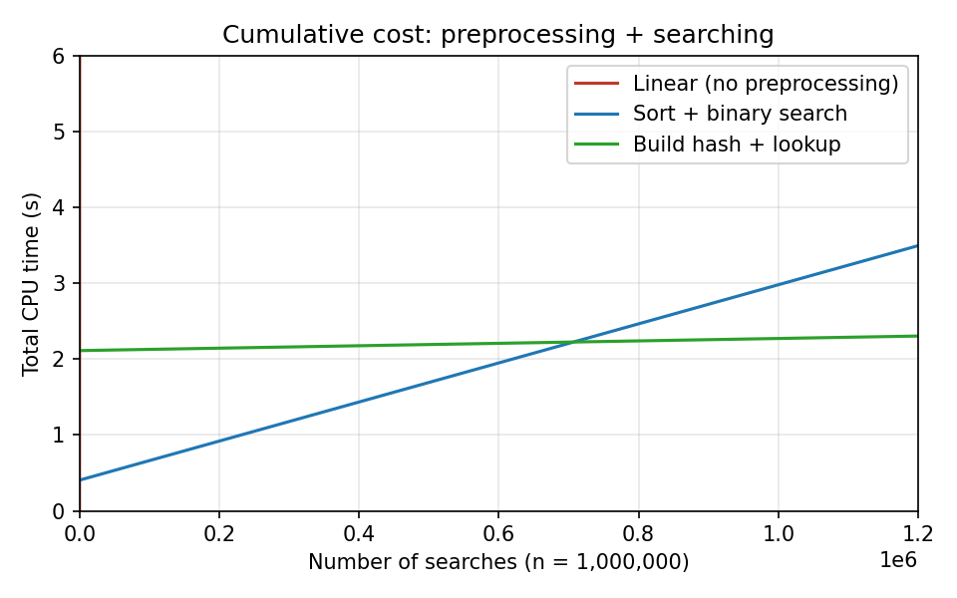
Figure 3: Cumulative CPU time at n = 10⁶. Linear is off-scale within ~200 searches; hash overtakes sort + binary after about 0.7 million searches (≈ 14 hours at 50,000/hour).
- Honest trade-off: in absolute terms both B and C comfortably handle 50,000 searches/hour (0.13 s vs 0.008 s of CPU per hour), so retaining binary search would also be defensible. I chose the hash index because the data is effectively static (so its weaknesses – updates and resizing – are avoided), it has the best total cost per day, it gives the best headroom if the request rate or database grows by 100×, and its latency per lookup is lowest. The costs are extra memory for the table (about m bucket pointers plus chain nodes), an O(n) worst case if the hash function is poor (mitigated by a prime m and by monitoring the maximum chain length: 8 in my tests), and no ordered queries (kept via the sorted array).
- Conclusion: Linear search is rejected; sort + binary search is a correct and safe baseline; the hash index rebuilt daily is the final design for the changed requirement. This follows from the analysis: high q, rare updates, Θ(n + q) total cost, 14.6× fewer comparisons, and a one-off 2.1 s rebuild.

Appendix – Source Code Used for the Experiments
import random, time, json, sys
sys.setrecursionlimit(10000)

# ---------- Algorithm A: Linear search (iterative) ----------
def linear_search(a, key):
for i in range(len(a)):
if a[i] == key:
return i
return -1
def linear_count(a, key):
c = 0
for i in range(len(a)):
c += 1
if a[i] == key:
return i, c
return -1, c

# ---------- Algorithm B: Binary search (recursive, needs sorted data) ----------
def bs_rec(a, key, lo, hi):
if lo > hi:
return -1
mid = (lo + hi) // 2
if a[mid] == key:
return mid
elif a[mid] < key:
return bs_rec(a, key, mid + 1, hi)
else:
return bs_rec(a, key, lo, mid - 1)
def bs_count(a, key):
lo, hi, c = 0, len(a) - 1, 0
while lo <= hi:
mid = (lo + hi) // 2
c += 1
if a[mid] == key: return mid, c
elif a[mid] < key: lo = mid + 1
else: hi = mid - 1
return -1, c

# ---------- Algorithm C: Hash table with chaining ----------
def next_prime(x):
def ip(n):
if n < 2: return False
i = 2
while i * i <= n:
if n % i == 0: return False
i += 1
return True
while not ip(x): x += 1
return x
def build_hash(a):
m = next_prime(len(a))
t = [None] * m
for k in a:
h = k % m
if t[h] is None: t[h] = [k]
else: t[h].append(k)
return t, m
def hash_search(t, m, key):
b = t[key % m]
if b is None: return False
for x in b:
if x == key: return True
return False
def hash_count(t, m, key):
b = t[key % m]; c = 0
if b is None: return False, 0
for x in b:
c += 1
if x == key: return True, c
return False, c

if __name__ == "__main__":
random.seed(42)
sizes = [1000, 10000, 100000, 1000000]
Q = 100
res = {}
for n in sizes:
keys = random.sample(range(10**8, 10**9), n) # unsorted registration numbers

